**Vision and Scope**

**Social Cell Network**

**Version 3.0 approved**

**Prepared by Team 2:**Pham Hong Phong  
Cao Duc Hiep  
Nguyen Sy Khang  
Tran Dinh Duc  
Nguyen Quang Minh  
Tran Quang Tung

**18 - 02 - 2024**

Table of Contents

**1. Business Requirements 3**

1.1. Background 4

1.2. Business Opportunity (Hiệp) 4

1.3. Business Objectives (Phong) 5

1.4. Success Metrics (Minh) 5

1.5. Vision Statement 6

1.6. Business Risks (hiệp) 6

1.7. Business Assumptions and Dependencies 6

Assumptions: 6

Dependencies: 7

**2. Scope and Limitations 7**

2.1. Major Features 8

2.2.. Scope of Initial and Subsequent Releases 9

2.4. Limitations and Exclusions (Hiệp ) 11

**3. Business Context 12**

3.1. Stakeholder Profiles 12

3.2. Project Priorities 13

Excellence in User Experience Design: 13

● Prioritize developing an intuitive and appealing user interface to simplify the cooking process. Integrate AI-driven personalization to suggest recipes and content based on user preferences, behavior, and seasonal trends. 13

Content Quality and Curation: 13

● Focus on curating a diverse range of culinary content catering to global cultures, dietary preferences, and skill levels. Establish a robust content management system to facilitate regular updates and contributions. 13

Scalability and Technical Reliability: 13

● Ensure the application architecture is scalable to accommodate user growth and content volume without compromising speed or reliability. Plan for cloud infrastructure to support dynamic scaling and data security. 13

Innovative Revenue Models: 13

● Explore diverse revenue streams aligned with user expectations and app value propositions. Include a combination of freemium features, subscription models, in-app purchases, and advertising partnerships. 13

Strategic Marketing and Brand Positioning: 13

● Develop a compelling brand identity highlighting the unique features of the application, community aspects, and commitment to culinary excellence. Implement a multi-channel marketing strategy leveraging social media, content marketing, and user engagement to build a loyal user base. 13

Commitment to Data Security and User Privacy: 13

● Implement industry-leading security measures to protect user data and ensure compliance with global privacy regulations. Build user trust through transparent communication and safe data handling practices. 14

3.3. Deployment Considerations (Đức Khang) 15

User Access 15

Revision History

| **Name** | **Date** | **Reason For Changes** | **Version** |
| --- | --- | --- | --- |
|  |  |  |  |
|  |  |  |  |

# **1.** **Business Requirements**

## **1.1.** **Background**

The Social Cell Network application is a specialized tool designed to manage personal and family matters by integrating features such as adding events to personal calendars, connecting families through family tree integration, and sharing memories with family members. It is developed to address the complex challenges of managing personal and family information across multiple platforms, creating a secure and private environment for users to optimize efficiency and communication within their families. The development history of the application stems from the recognition of the increasing demand among users for a comprehensive solution to manage personal and family life more easily and safely.

## **1.2.** **Business Opportunity**

The business opportunity of the product is aimed at middle-aged users. When one family member uses a product, everyone in the family will also use that product. In addition, young people tend not to pay attention to event times and information

## **1.3.** **Business Objectives**

The product's business goal is aimed at middle-aged users. When one family member uses a product, everyone in the family will also use that product. In addition, young people tend not to pay attention to time and event information.

## **1.4.** **Success Metrics**

1. **New user registrations**: This metric indicates the growth of the platform. A steady increase in the number of new users demonstrates the platform's attractiveness to new users.
2. **Engagement rate**: This is the ratio of active users on the platform (such as interacting with posts, commenting) to the total number of users. A high engagement rate indicates an active community and the platform generating significant value for users.
3. **Average time spent**: Measure the amount of time each user spends using the platform. A high average usage time shows that the platform meets the needs and desires of users.
4. **User satisfaction**: Use surveys or feedback from users to assess their satisfaction with the platform. The goal is to create a good user experience that meets their desires and needs.
5. **Profit:** While the primary goal may not be profit, achieving profit from revenue sources such as advertising, sponsorship, or sales can be considered an important success criterion. Profit should be sufficient to sustain and develop the project.

## 

## **1.5.** **Vision Statement**

For individuals seeking to streamline their management of personal and family events, Social Cell Network offers a web-based and mobile-supported platform that not only simplifies event logging but also enhances connection among family members. Unlike traditional manual or disparate digital solutions, our platform centralizes family interactions, merging calendars, and social updates in one intuitive application. This ensures that no significant moment or event is missed or forgotten, fostering stronger bonds through shared experiences and memories. Through Social Cell Network, we envision a world where every family member, regardless of their location, can feel closely connected, contributing to a tapestry of family heritage that is rich, accessible, and engaging.

## **1.6.** **Business Assumptions and Dependencies**

### **1.6.1 Assumptions:**

* **User Adoption:** It is assumed that users will readily embrace the new social cell network (SCN) platform and actively engage with its features and functionalities.
* **Technical Compatibility:** The SCN platform is assumed to be compatible with commonly used web browsers and operating systems, ensuring accessibility for a wide range of users.
* **Data Security:** It is assumed that the implemented security measures, including encryption protocols and access controls, will effectively safeguard user data and privacy within the SCN platform.
* **Stakeholder Support:** The success of the project relies on ongoing support and collaboration from key stakeholders, including management, IT personnel, and end-users, throughout the development and deployment phases.

### **1.6.2 Dependencies**:

* **Third-Party Integration:** The project depends on successful integration with third-party services or APIs for functionalities such as email notifications,...
* **Technology Stack:** The project relies on specific technologies and frameworks, such as web development languages (e.g., HTML, CSS, JavaScript), backend databases, and server infrastructure, to build and deploy the SCN platform.
* **Development Partners:** Dependencies exist on external development partners or vendors for specialized expertise or resources required during the project lifecycle, such as infrastructure setup.
* **Regulatory Compliance:** The project must adhere to relevant data protection regulations and industry standards, imposing dependencies on legal counsel and compliance experts to ensure adherence to legal requirements.
* **User Training and Support:** The successful adoption of the SCN platform depends on comprehensive user training and ongoing support services, requiring collaboration with training providers or internal resources to deliver effective training programs and support mechanisms.
* **Marketing and Promotion:** Dependencies exist on marketing efforts to promote the SCN platform and attract users, requiring coordination with marketing teams or external agencies to develop marketing strategies and campaigns.

# **2.** **Scope and Limitations**

## **2.1.** **Major Features**

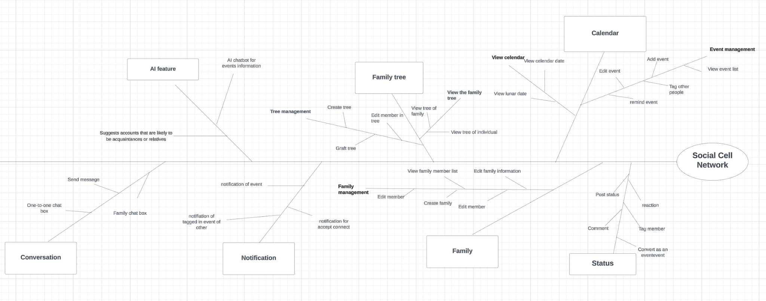

## **2.2..** **Scope of Initial and Subsequent Releases**

| **Feature** | **Release 1** | **Release 2** | **Release 3** | |
| --- | --- | --- | --- | --- |
| FE-1 | User interface: Develop a user-friendly interface with intuitive navigation and appealing design. |  |  |  |
| FE-2 | Allows users to search for members via phone number. Displays members' basic profile information after searching. |  |  |  |
| FE-3 | Allows users to view and edit personal profile information.Includes information fields such as name, profile picture, description, etc. |  |  |  |
| FE-4 | Allows users to create and manage personal events on the calendar Include information such as title, date, location, and event description. | Allows users to tag friends in their events, edit the view to private or public |  |  |
| FE-5 | Users can create and post personal statuses. Allows adding text and images to the status | Allows users to edit privacy such as making posts public or private, adding friends to status |  |  |
| FE-6 | Users can create a new family group. Provides features to add members, delete members, edit member permissions, edit information and delete family groups. | Users can create events for family group events. Provides the ability to tag family members to participate in events. |  |  |
| FE-7 | Users can chat with relatives, chat in family groups |  |  |  |
| FE-8 | Users can create and manage their family tree. | Allows users to view, edit, search, add, and delete family members in the family tree. |  |  |

## 

# **3.** **Business Context**

## **3.1.** **Stakeholder Profiles**

**1. End Users (Members of Social Cell Network):**

- Demographics: Users vary widely, from young adults exploring family connections to elderly individuals interested in genealogy.

- Needs and Expectations: They desire a user-friendly platform for connecting with family members, sharing memories, managing events, and collaborating on family trees. Privacy and security are paramount concerns.

- Engagement Strategies: Implement user-friendly interface designs, personalized content recommendations, event reminders, and secure data encryption to enhance user engagement and trust.

**2. Developers and Designers:**

- Profile: A team of skilled developers, designers, and IT specialists.

- Needs and Expectations: Clear project requirements, adequate resources, and a collaborative work environment. They prioritize innovation, scalability, and seamless integration of features.

- Engagement Strategies: Regular feedback sessions, agile development methodologies, and recognition of individual contributions to foster creativity and teamwork.

**3. Investors and Stakeholders:**

- Profile: Venture capitalists, angel investors, and stakeholders interested in the project's success.

- Needs and Expectations: Clear business objectives, growth projections, and a viable monetization strategy. They seek transparency, regular updates, and a roadmap for future development.

- Engagement Strategies: Comprehensive business plans, progress reports, and regular communication to build trust and attract investment.

**4. Family Historians and Genealogy Enthusiasts:**

- Profile: Individuals passionate about researching and preserving family history.

- Needs and Expectations: Access to comprehensive genealogical records, collaboration tools for family research, and integration with other genealogy platforms.

- Engagement Strategies: Provide access to extensive historical archives, collaborative family tree tools, and expert resources to support genealogical research.

## **3.2.** **Project Priorities**

**1. Excellent user experience:**

Emphasize creates an intuitive and visually appealing user interface to streamline social interactions, calendars, and family trees. Use AI-powered customization to recommend content and connections based on user interests, behavior, and trending topics.

**2.Content quality and management:**

Focus on managing different types of content, interactions, and engagement levels within social networks. Set up a robust content management system to allow for regular updates and user contributions.

**3.Scalability and technical reliability:**

Ensure the platform's architecture can scale seamlessly to accommodate a growing user base and increasing content volume while maintaining optimal performance and reliability.

**4.Innovative revenue model:**

Explore innovative revenue streams that align with user preferences and platform offerings. Combine premium features, subscription options, in-app purchases, and strategic advertising partnerships to drive business.

**5. Strategic brand positioning and marketing:**

Develop a compelling brand identity that highlights the platform's unique features, community dynamics, and commitment to fostering meaningful social connections. Execute a comprehensive marketing strategy across multiple channels, including social media, content marketing, and user engagement initiatives to cultivate a dedicated user base.

**6.Committed to data security and user privacy:**

Implement strong security protocols to secure user data and ensure compliance with global privacy regulations. Promote user trust through transparent communication and responsible data management practices.

## **3.3.** **Deployment Considerations**

### **User Access:**

* Identify the distribution of users across different locations and time zones.
* Determine the access requirements for users, including whether they will access the system remotely or from a centralized location.
* Specify when users in various locations need to access the system and ensure availability accordingly.

### **Qq2 Data Migration:**

* Evaluate the data migration process from existing systems to the new solution.
* Identify data migration tools and methodologies to transfer data securely and accurately.
* Ensure compatibility and integrity of data during the migration process.

### **Training and Business Process Modification:**

* Develop training materials and resources for users to familiarize themselves with the new system.
* Conduct training sessions for users to ensure they understand how to effectively utilize the features and functionalities of the solution.
* Collaborate with relevant stakeholders to modify existing business processes to align with the capabilities of the new solution.
* Document any changes to business processes and provide guidance on their implementation during deployment.

### **Testing and Validation:**

* Conduct comprehensive testing of the solution in a staging environment to identify and address any potential issues or bugs.
* Validate the functionality and performance of the solution under real-world conditions to ensure readiness for deployment.
* Engage end-users in user acceptance testing (UAT) to gather feedback and make necessary refinements before final deployment.

### **Deployment Plan:**

* Develop a detailed deployment plan outlining the sequence of activities, timelines, and responsibilities for each deployment phase.
* Communicate deployment schedules and expectations to all stakeholders to ensure a smooth transition to the new solution.